Practical - 13
Practical Title: PHP JSON API and AJAX/Fetch-Based CRUD without Page Reload

Problem Definition : Create simple PHP JSON API endpoints for events or students and consume them using Fetch API. Perform list, add, update, and delete operations asynchronously without full page reload.

Theory
1. Do PHP endpoints return valid JSON responses? Yes, PHP endpoints return valid JSON responses using json_encode() for event data, success messages, and error messages.

2. Are GET and POST requests handled properly? Yes, GET requests fetch and display events, while POST requests add new events to the database. PUT and DELETE requests are also used to update and delete events.

3. Are loading, success, and error states shown on the frontend? Yes, the frontend displays a loading message while fetching events, success messages after operations, and error messages when a request fails.

4. Is input validation performed before database operations? Yes, required fields are checked before database operations, and prepared statements are used to help prevent SQL injection. Frontend validation is also performed using HTML required fields and JavaScript.

A. Evidence of Work (Screenshots):
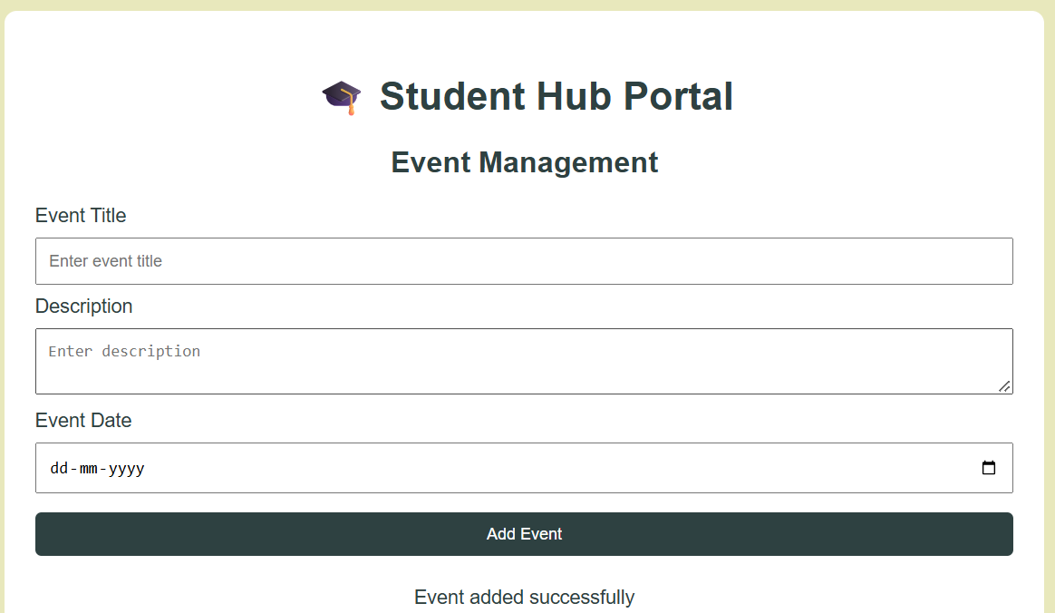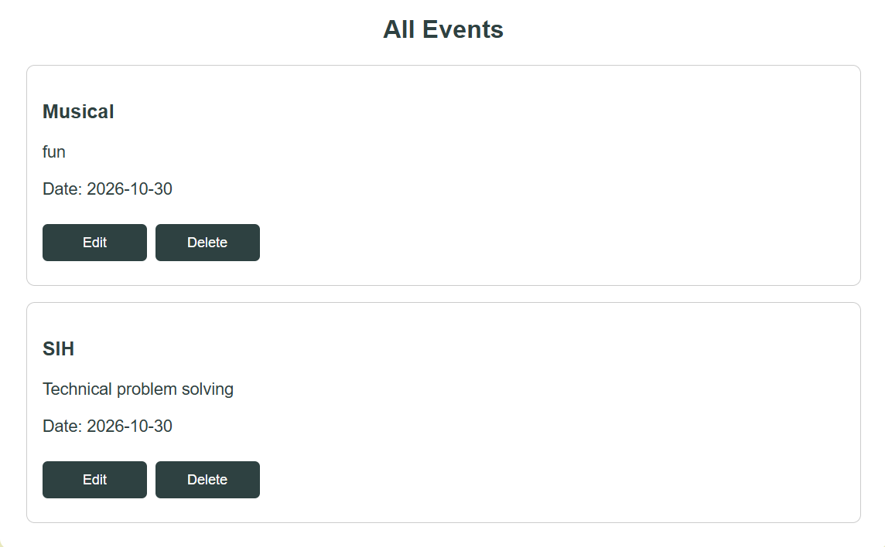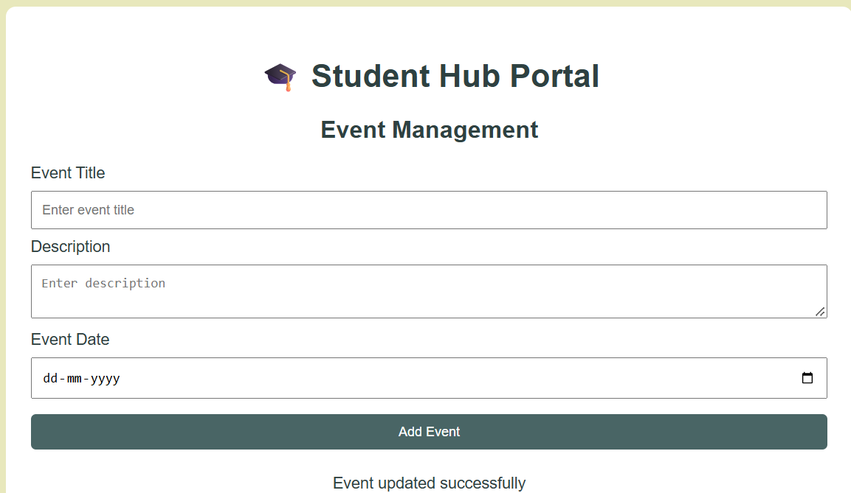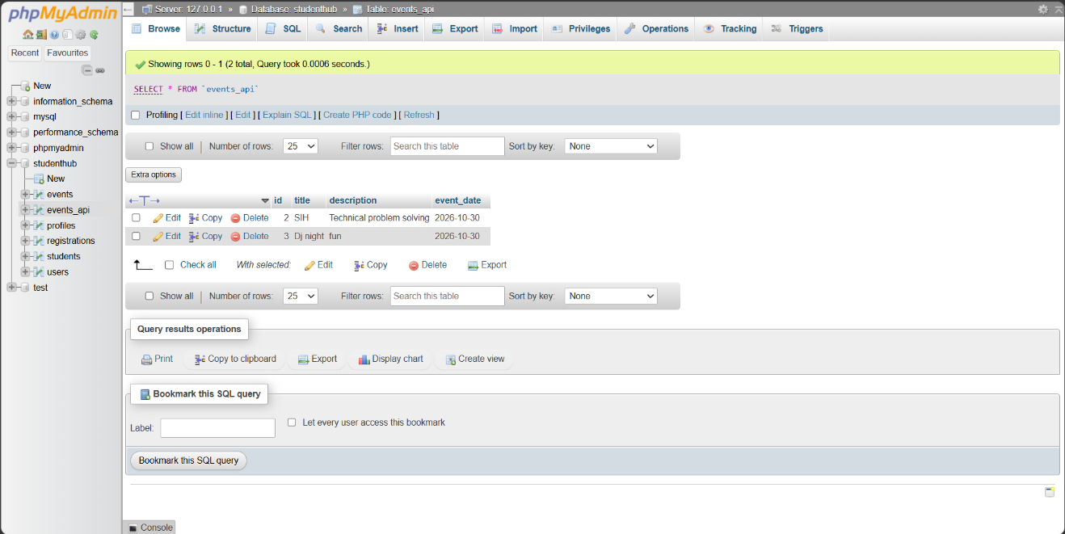
B.GitHub Repository Link:
https://github.com/Andarpadhruvi1125/Student-Hub-portal.git
C. Challenges Faced
While performing Practical 13, I faced challenges in connecting PHP with the MySQL database and handling JSON data. I also learned how to use the Fetch API to perform CRUD operations without reloading the webpage. Debugging errors and validating user input were other challenges.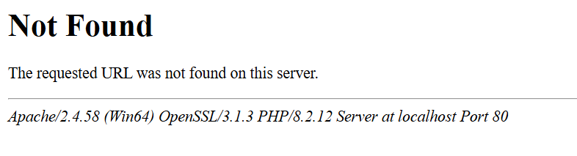
D.Learning Outcomes
I learned how to create PHP JSON API endpoints and use the Fetch API to send GET, POST, PUT, and DELETE requests. I also learned to display events dynamically, validate input, and show loading, success, and error messages without refreshing the page.
Faculty Remarks:

